|  |  |
| --- | --- |
| https://user-cdn.uef.edu.vn/newsimg/files/logo%20nhan%20dien%20TH/3.jpg | **HCM UNIVERSITY OF ECONOMICS AND FINANCE**  **FACULTY OF INFORMATION TECHNOLOGY** |

**FINAL PROJECT**

**SUBJECT: DEVELOPING ARTIFICIAL INTELLIGENCE   
Lecturer: Msc. Trần Thành Công**

**PROJECT NAME**

**FACE REGCONITION**

*Team Members:*

1. Văn Hoàng Phúc – 185050810
2. Tạ Đức Huy – 185050775

Ho Chi Minh city – 2022

Contents

CHAPTER 1. INTRODUCTION 2

1.1. PURPOSE 2

1.2. SCOPE 3

CHAPTER 2. DATASET 3

2.1. COLLECTING DATASET 3

2.2. DATA UNDERSTANDING 4

CHAPTER 3. ALGORITHMS AND EVALUATION METHODS 5

3.1. ALGORITHMS 5

3.1.1. Support Vector Machine (SVM) 5

3.1.2. Convolutional Neural Networks (CNN) 5

3.2. EVALUATION METHODS 5

3.2.1. Accuracy 5

3.2.2. Confusion Matrix 5

3.2.3. F1-Score 6

CHAPTER 4. SUPPORT VECTOR MACHINE (SVM) 6

4.1. DATA PREPARATION FOR SVM MODEL 6

4.2. TRAINING SVM MODEL 9

4.3. EVALUATION OF SVM MODEL 10

CHAPTER 5. CONVOLUTIONAL NEURAL NETWORKS (CNN) 13

5.1. DATA PREPARATION FOR CNN MODEL 13

5.2. TRAINING CNN MODEL 16

5.3. EVALUATION OF CNN MODEL 16

CHAPTER 6. DEPLOYMENT 19

CHAPTER 7. CONCLUSION 20

7.1. RESULT 20

7. LIMITATIONS 21

CHAPTER 8. REFERENCES 21

**LIST OF FIGURES**

Figure 2‑1 : Download dataset from Kaggle.com 5

Figure 2‑2: 656 images of 30 people 5

Figure 4‑1 : Loading ‘facenet_keras.h5’ model 7

Figure 4‑2 : Creating a function to extracting high-quality features 7

Figure 4‑3 : Creating load_faces function 8

Figure 4‑4 : Return dataset as 2d matrix 9

Figure 4‑5 : Loading dataset for SVM model 9

Figure 4‑6 : Splitting dataset for SVM model 10

Figure 4‑7 : Training SVM model 11

Figure 4‑8 : Accuracy score of SVM model 12

Figure 4‑9 : F1-score of SVM model 13

Figure 4‑10 : Confusion matrix of SVM model 14

Figure 5‑1 : Creating ‘load_faces’ function for CNN model 15

Figure 5‑2 : Loading dataset for CNN model 16

Figure 5‑3 : Splitting dataset for CNN model 16

Figure 5‑4 : Traing CNN model 17

Figure 5‑5 : Training accuracy and training loss of CNN model 18

Figure 5‑6 : Testing accuracy and testing loss of CNN model 18

Figure 5‑7 : F1-score of CNN model 19

Figure 5‑8 : Confusion matrix of CNN model 20

Figure 6‑1 : Implementing face detection model by Gradio library 21

Figure 6‑2 : Face detection website 21

# INTRODUCTION

AI stands for artificial intelligence, which is a branch in computer science field. AI is an intelligence which is created by humans with the goal of helping computers to automate intelligent behaviors like humans. Artificial intelligent differs from logic programming languages in the application of machine learning systems to imitate human intelligence in the progresses that humans can do better than computers. Specifically, artificial intelligence helps computers acquire human intelligence such as knowing how to think and conclude to solve problems, knowing how to communicate by understanding language and speech…

There are some outstanding applications of artificial intelligence which can support a lot in life. An AI technology called facial recognition technology allows people who use social media platforms tag and share photos of friends. Another technology called optical character recognition technology, which can help to convert images of text into movable type. recommendation engines, powered by machine learning, suggest what movies or television shows to watch next based on user preferences, thank to this technology people can know more about great videos on the internet.

In this face recognition project, we research about face recognition technology in AI, how to collect, analyze and prepare dataset. We also research about the mathematical models in machine learning and deep learning such as SVM and CNN. Besides, building up mathematical models, we deploy them into a website to serve for working purposes.

## PURPOSE

Based on the knowledge that we learned from machine learning subject, about collecting data, preparing dataset, algorithms for model and evaluating quality of model, we build a mathematical model and deploy it into a website to recognize faces of human through camera. Face recognition is a classification problem and dataset of this project is image, so the solution for this problem is using 2 algorithms in supervised learning, which are called Convolutional Neural Networks (CNN) and Support Vector Machine (SVM) to recognize faces, and we will evaluate which one is the best algorithm for this problem and deploy it into a face recognition website.

In addition, the goal through this project can be determined to think about collecting understanding data, the data preparation, applying model for data, evaluating the quality of model, and deploy model into a website. we also understand more about algorithms for the model, how it works with the dataset and tools to help deploy model into website.

## SCOPE

* The project is implemented on the basic of the machine learning subject and developing AI application subject, the knowledge about data preparation, building model, evaluating model and deploy model into website.
* The scope of the project is limited in understanding and preparing dataset for model, build up and deploy the model for face recognition.

# DATASET

## COLLECTING DATASET

The first step in this project, we have to collect the dataset for mathematical model to detect faces of human, so we will find dataset on some websites which is human’s face images. In this case study, the website that we use to collect the dataset is Kaggle.com, this website is used by people who research about mathematical model in machine learning and deep learning, and it allows people to download the dataset from the studies of other people.



Figure ‑ : Download dataset from Kaggle.com

## DATA UNDERSTANDING

In the dataset that we downloaded from Kaggle website, there are tons of human’s face images. Since the downloaded dataset is too large, so we decided to take images of 28 people in the dataset and images of 2 member in research team, totally 656 images of 30 people to create a new dataset which has smaller size.

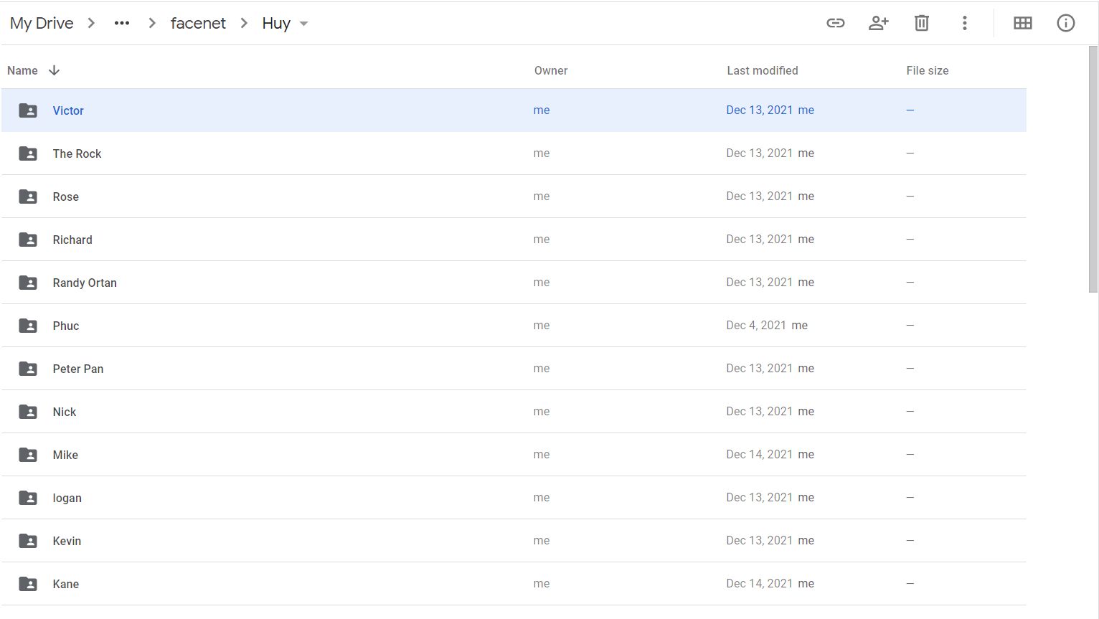

Figure ‑: 656 images of 30 people

# ALGORITHMS AND EVALUATION METHODS

## ALGORITHMS

### Support Vector Machine (SVM)

Support vector machine or SVM is a supervised machine learning algorithm which can be used for classification or regression problems. It uses a technique called the kernel trick to transform your data and then based on these transformations it finds an optimal boundary between the possible outputs.

### Convolutional Neural Networks (CNN)

A convolutional neural networks or CNN is a class of deep neural networks, it has one or more convolutional layers and are used mainly for image processing, classification, segmentation and also for other auto correlated data. CNN uses a special technique called “convolution” and this term in mathematics is a mathematical operation on two functions that produces a third function that expresses how the shape of one is modified by the other.

## EVALUATION METHODS

### Accuracy

Measurement accuracy is defined as the closeness of agreement between a measured quantity value and a true quantity value.

### Confusion Matrix

In the field of machine learning and specifically the problem of statistical classification, a confusion matrix, also known as an error matrix, is a specific table layout that allows visualization of the performance of an algorithm, typically a supervised learning.

### F1-Score

The F1-Score is a measure of a model’s accuracy on a dataset. It is used to evaluate binary classification systems, which classify examples into ‘positive’ or ‘negative’.

The F1-Score is a way of combining the precision and recall of the model, and it is defined as the harmonic mean of the model’s precision and recall.

# SUPPORT VECTOR MACHINE (SVM)

## DATA PREPARATION FOR SVM MODEL

The first thing we do in this section is downloading model file called ‘facenet_keras.h5’ and loading this model in the project. The ‘facenet_keras.h5’ model can help to extract high-quality features from the face and predict a 128 elements vector which represent these features, called a face embedding.

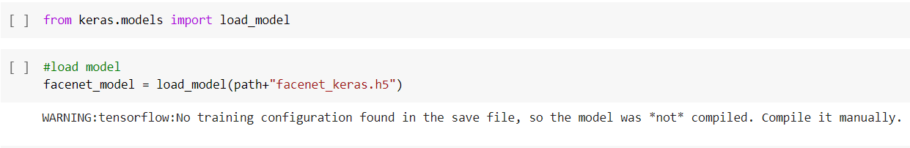

Figure ‑ : Loading ‘facenet_keras.h5’ model

Next, we create a function called get_embedding, this function can help to extract the high-quality features from face images by using ‘facenet_keras.h5’ model in it. Before getting the high-quality features through the model, we have to prepare suitable pixel values of images for ‘facenet_keras.h5’ model in this function.

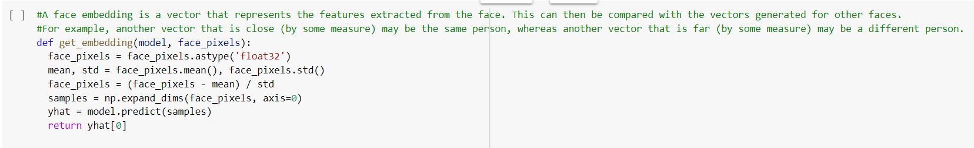

Figure ‑ : Creating a function to extracting high-quality features

After creating get_embedding function, we have to create a function called load_faces to load the images, covert images into suitable data. In load_faces function, we also put get_embedding function into it to extract high-quality features from images and this function will return a 2d matrix.

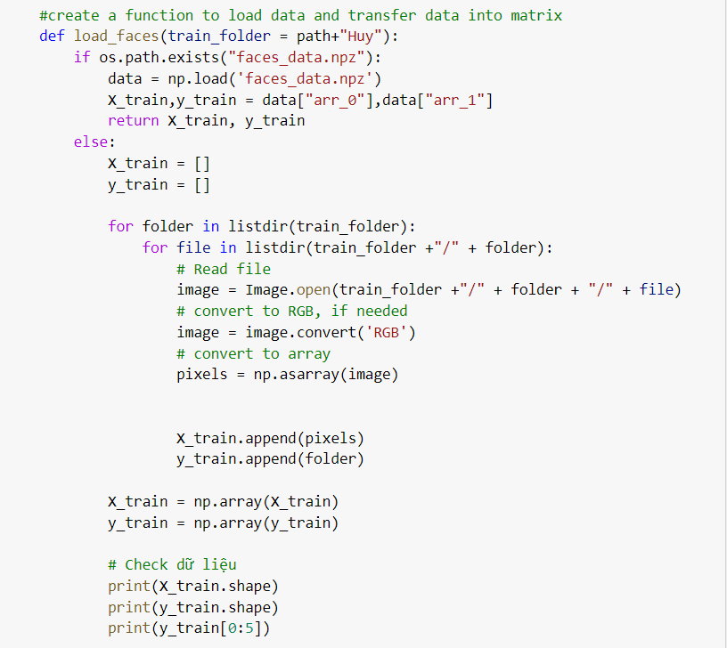

Figure ‑ : Creating load_faces function

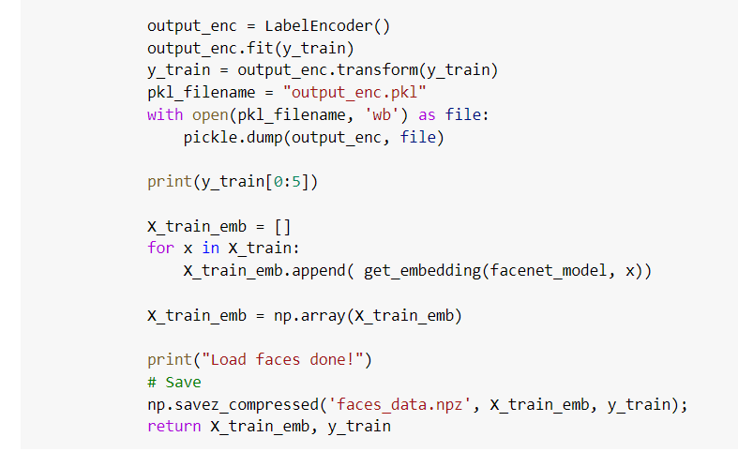

Figure ‑ : Return dataset as 2d matrix

The next stage, we will call ‘load_faces’ function to load the dataset and show the shape of dataset.

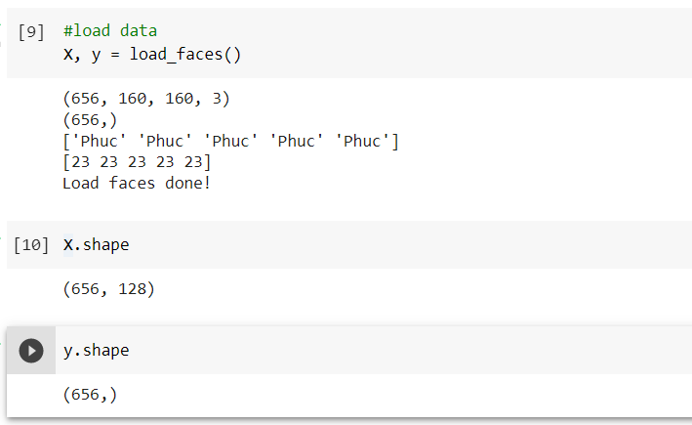

Figure ‑ : Loading dataset for SVM model

The next step, we split the dataset into 2 parts for training and testing model. The training part is 80% of dataset and the testing part is 20% of dataset.

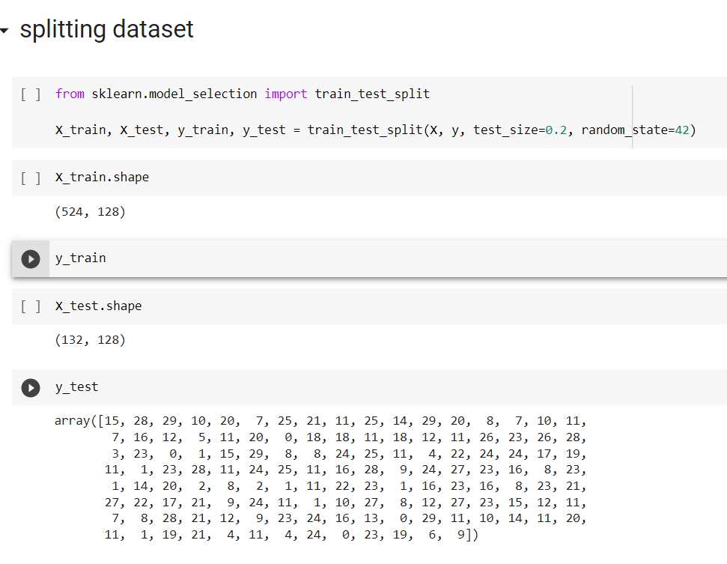

Figure ‑ : Splitting dataset for SVM model

## TRAINING SVM MODEL

After we do the data preparation, we will use processed dataset for SVM model to train. There are some properties in SVM model such as kernel and probability. In the property kernel, we put ‘linear’ on it and probability is ‘True’.

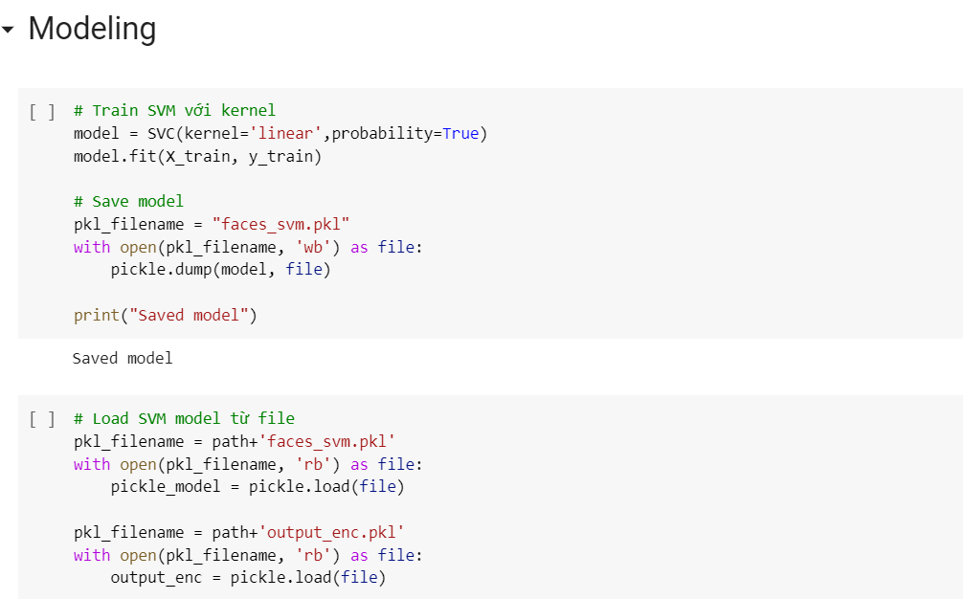

Figure ‑ : Training SVM model

## EVALUATION OF SVM MODEL

In order to evaluate the quality of SVM model, we use some measurements such as accuracy score, f1-score and confusion matrix. The accuracy of SVM model is quite high, is about 100% for training and 96,2% for testing. The values for f1-score are quite high for testing, 100% account for the most, but there are still cases have f1-score lower.

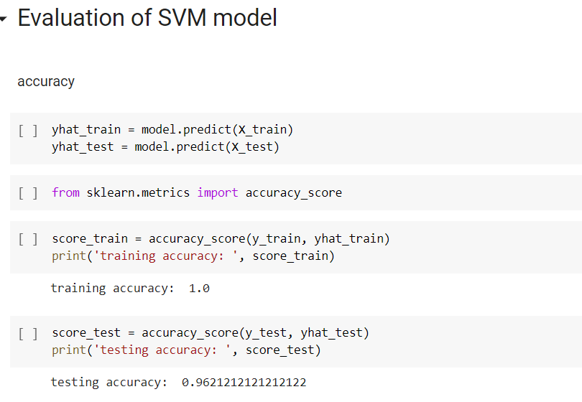

Figure ‑ : Accuracy score of SVM model

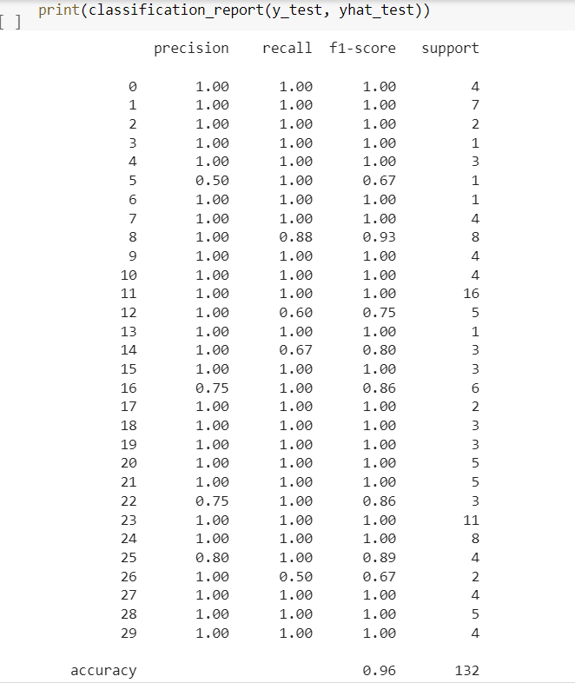

Figure ‑ : F1-score of SVM model

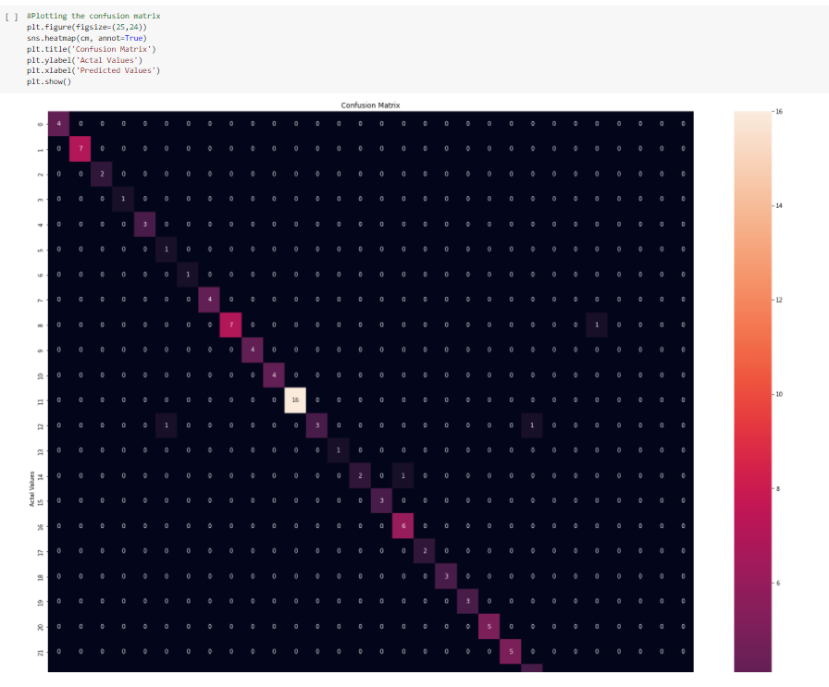

Figure ‑ : Confusion matrix of SVM model

# CONVOLUTIONAL NEURAL NETWORKS (CNN)

## DATA PREPARATION FOR CNN MODEL

In the data preparation for CNN model, we still use the function ‘load_faces’, but we remove the get_embedding function into it and convert images into 3d matrix to make the dataset become suitable for CNN model.

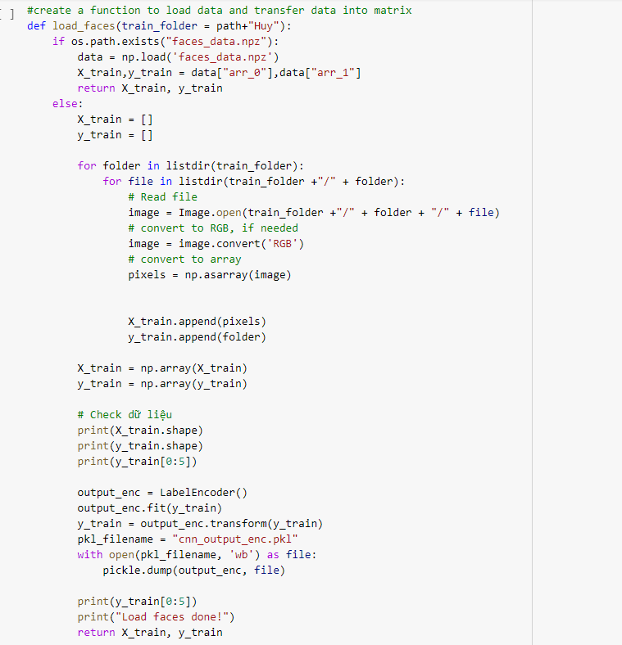

Figure ‑ : Creating ‘load_faces’ function for CNN model

The following step, we use the function ‘load_faces’ to load dataset for CNN model, and we also show the shape of dataset.

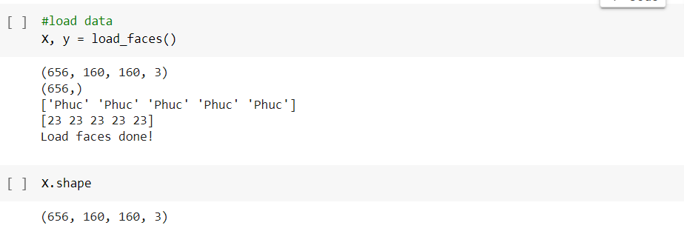

Figure ‑ : Loading dataset for CNN model

The next stage, we split the dataset that we have just loaded into 2 parts, training and testing for CNN model. Training part accounts for 80% and testing part accounts for 20%.

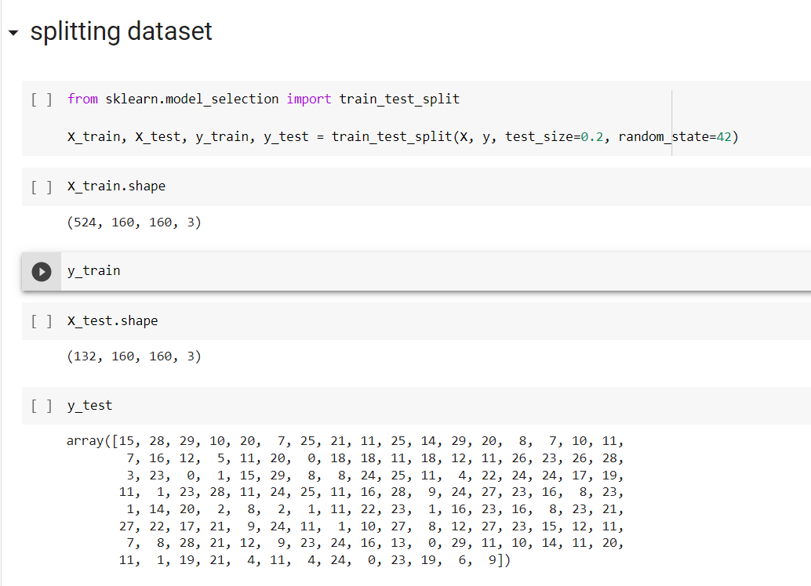

Figure ‑ : Splitting dataset for CNN model

## TRAINING CNN MODEL

After do the preparation for CNN model, we use the processed data for the model, and we also adjust some properties for CNN model, the activation of hidden layers is ‘relu’ and the activation of output layer is ‘softmax’. In this study case, we have to use ‘softmax’ in the output, because face recognition is a multiple classification. The batch_size for CNN model is 20 and epochs is 5.

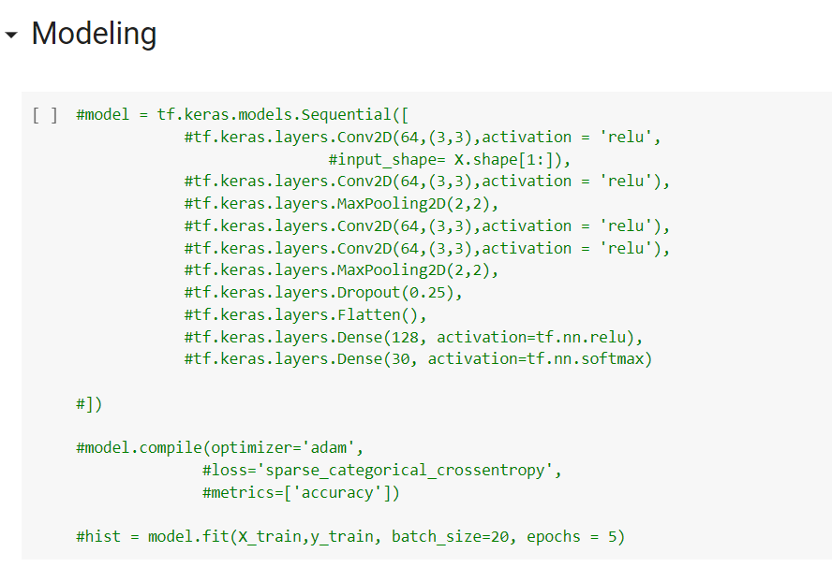

Figure ‑ : Traing CNN model

## EVALUATION OF CNN MODEL

For CNN model, we use some measurements to evaluate the model such as accuracy score, loss score, f1-score and confusion matrix. The values for training accuracy and training loss are pretty good, about 90% for training accuracy and almost 0 for training loss, but testing accuracy is quite low, about 36,3% and testing loss is about 4.099, which means CNN model is overfitting. The values for f1-score are also low, so the CNN model has bad performance.

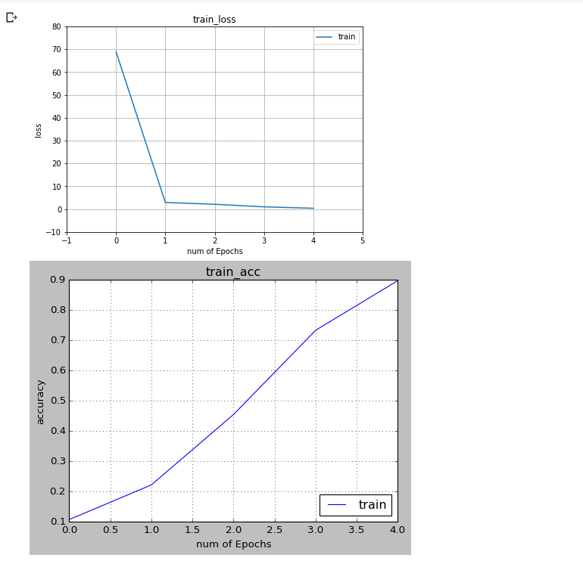

Figure ‑ : Training accuracy and training loss of CNN model

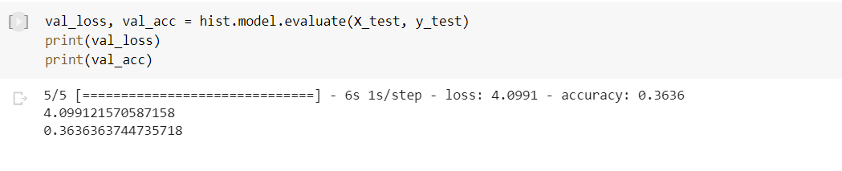

Figure ‑ : Testing accuracy and testing loss of CNN model

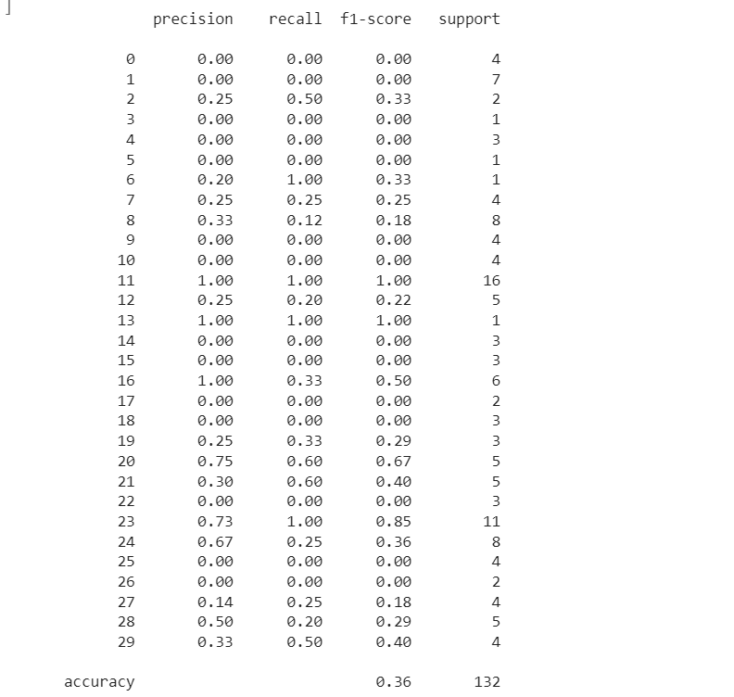

Figure ‑ : F1-score of CNN model

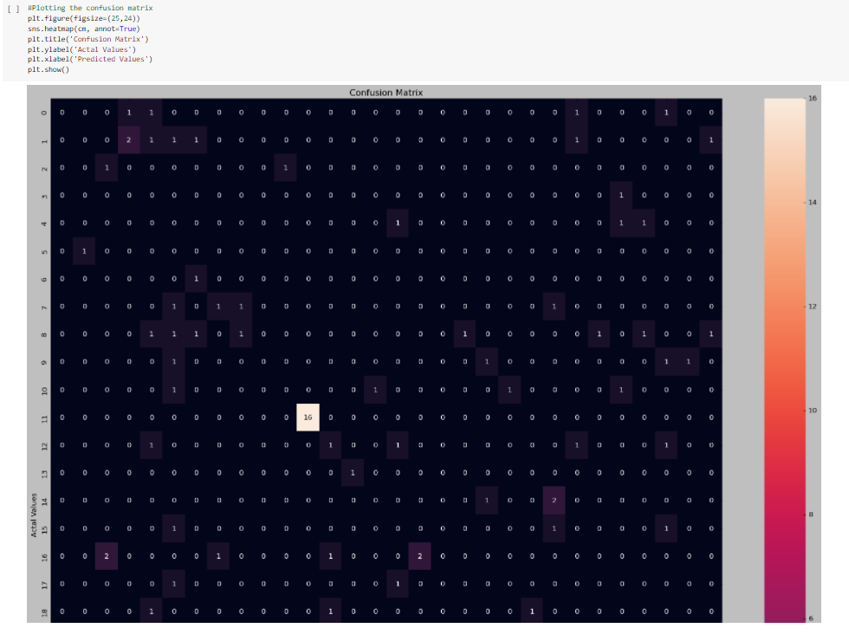

Figure ‑ : Confusion matrix of CNN model

# DEPLOYMENT

In this stage, we deploy model on the web by using Gradio library. Gradio is the fastest way to demo machine learning model with a friendly web interface so that anyone can use it. A Gradio interface can automatically generate a public link you can share with colleagues that lets them interact with the model on your computer remotely from their own devices.

In Predict_face function we created to get prediction from model and return output to the website, there are two steps. The first step is to detect the face by using the library MTCNN. which model will find the location of the face in image and from that location we put it to Embedding layer to extract high-quality features. The final step, we use the Support vector machine model to predict information that we got features from Embedding layer.

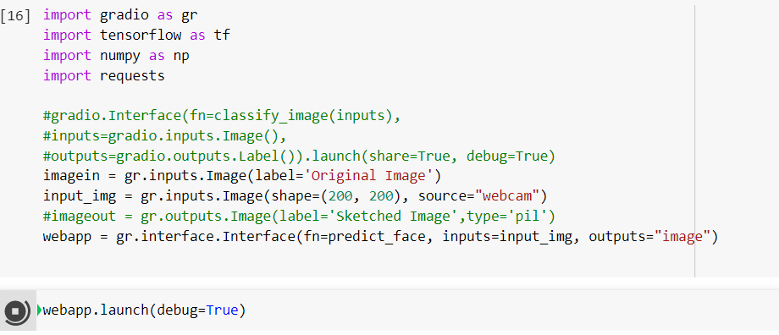

Figure ‑ : Implementing face detection model by Gradio library



Figure ‑ : Face detection website

# CONCLUSION

## RESULT

After analyzing and building up mathematical models detect faces of human, we realize that Support Vector Machine is suitable for this problem because the evaluation of it is better than Convolutional Neural Networks. Based on the SVM model which is trained for face recognition and the assistance of gradio library, we can apply the model into a website to detect faces of human. Besides, Besides, we also have a plan to develop this face detection website in the future, we will improve the interface of website and add some functions to make it better.

## LIMITATIONS

In the process of researching and developing mathematical models and website, we find out some limitations such as processing and tech limits, public trust and human engineering. These limitations cause difficulties in modeling and website development.

# REFERENCES

## <https://www.kaggle.com/dansbecker/5-celebrity-faces-dataset?fbclid=IwAR3eMsZPQC_WguDUo5rAWejfg5J1PB_bYOI6QGXQADtPwsBaLx2EndOUYUI>

## <https://machinelearningmastery.com/how-to-develop-a-face-recognition-system-using-facenet-in-keras-and-an-svm-classifier/?fbclid=IwAR39ScFgZmDb8j1QsEGeRtALUm7WLIhKd4t3MahVwGzkUcJ48WCIm7slkAg>

* <https://www.kaggle.com/aditya48/real-and-fake-face-detection?fbclid=IwAR37y6jU2VtBVkipUKgUAwkMvmOreXhsvV8av-eKo9gsmV2LXwre8TMIm2w>
* <https://www.youtube.com/watch?v=Qdwq1K-3z_E>